**Question 1**(30 points)

Hey,

You have to create Recipe application according to following design

1. Get started Screen
2. Home Screen-> When you have to add navigation drawer "Home", "Saved", "Add To card", "Profile". This navigation drawer is the same which we have done means sliding menu.

On Home Screen when user click on recipe image it will redirect to next screen

    3. Recipe detail screen.

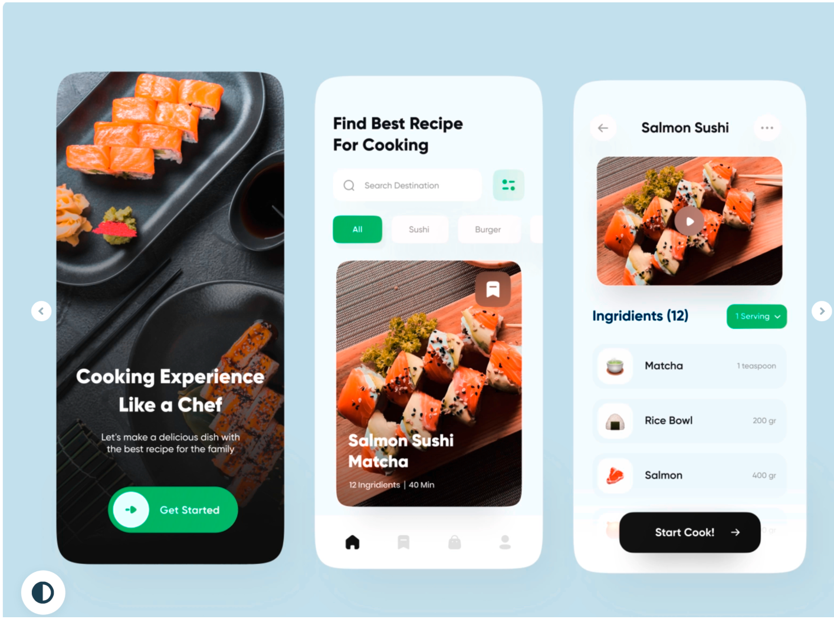

Note: Please send the project folder alone with screenshots of your emulator.

Ans:

1. Get started Screen
2. Home Screen-> with menu and navigation drawer "Home", "Save", "Add to cart", "Profile". This navigation drawer is the same which we have done means sliding menu.
3. Just made the required as per the screens and their navigations
4. On 2nd Screen when user clicks on recipe image it will redirect to next screen Recipe detail screen.

Start Screen

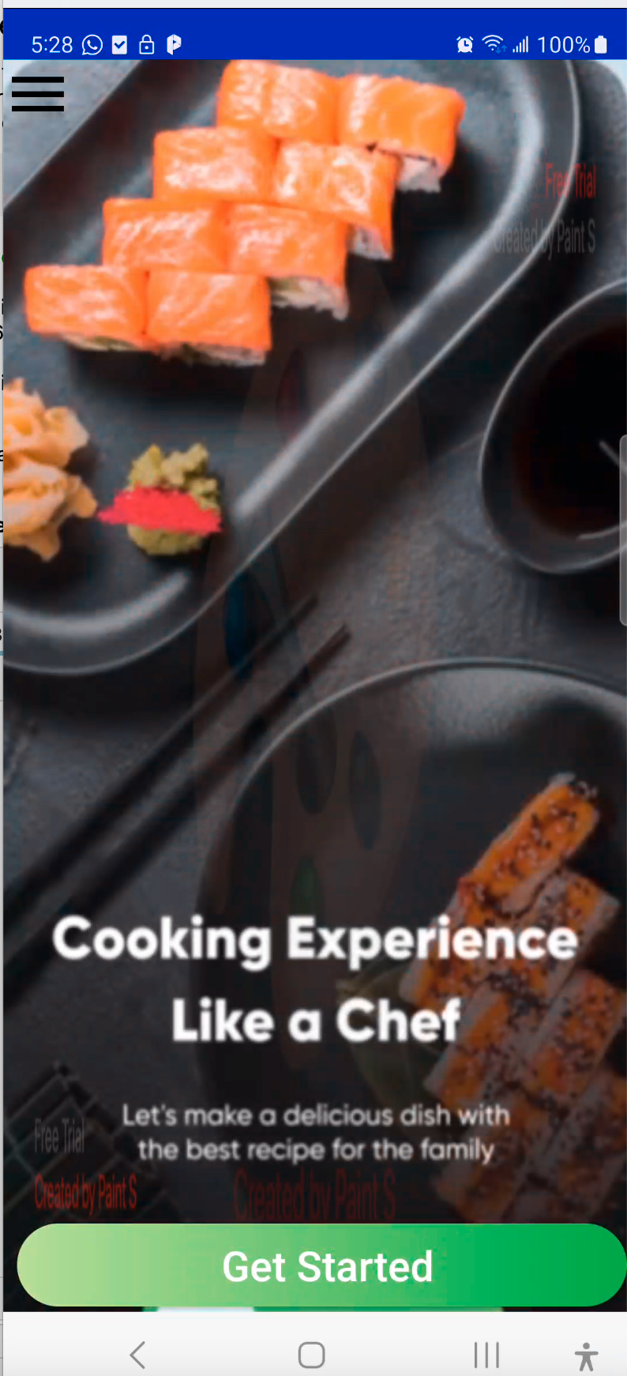 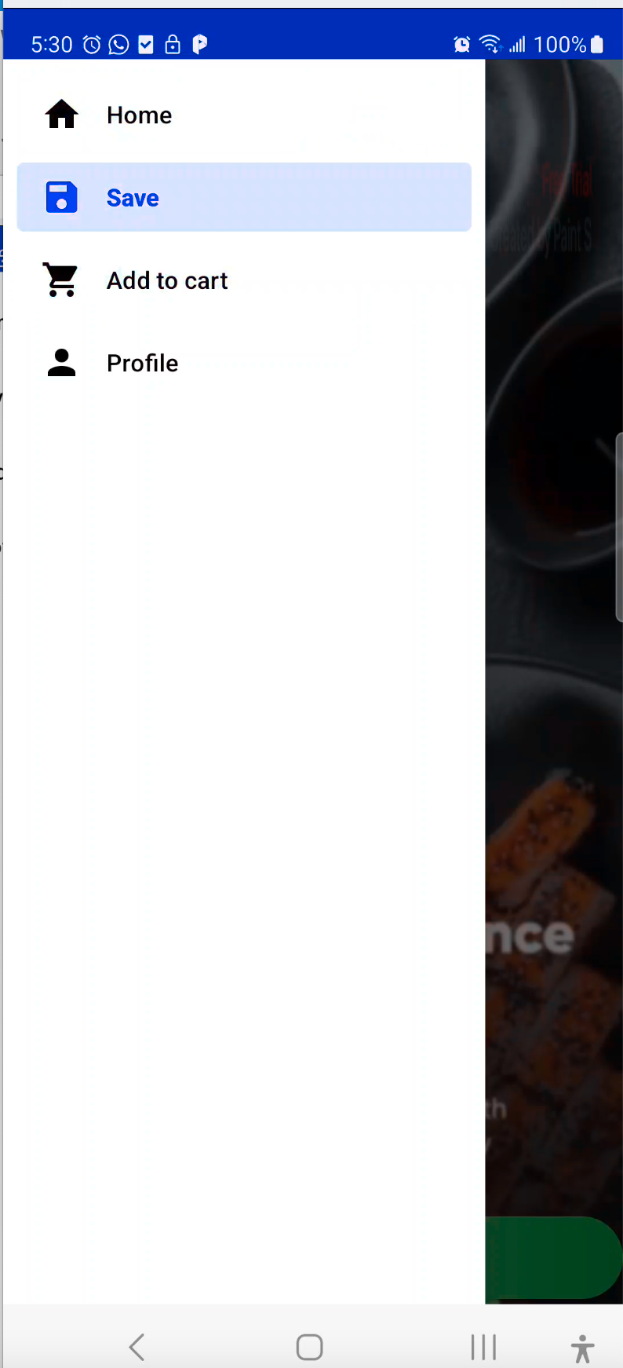

Second Screen

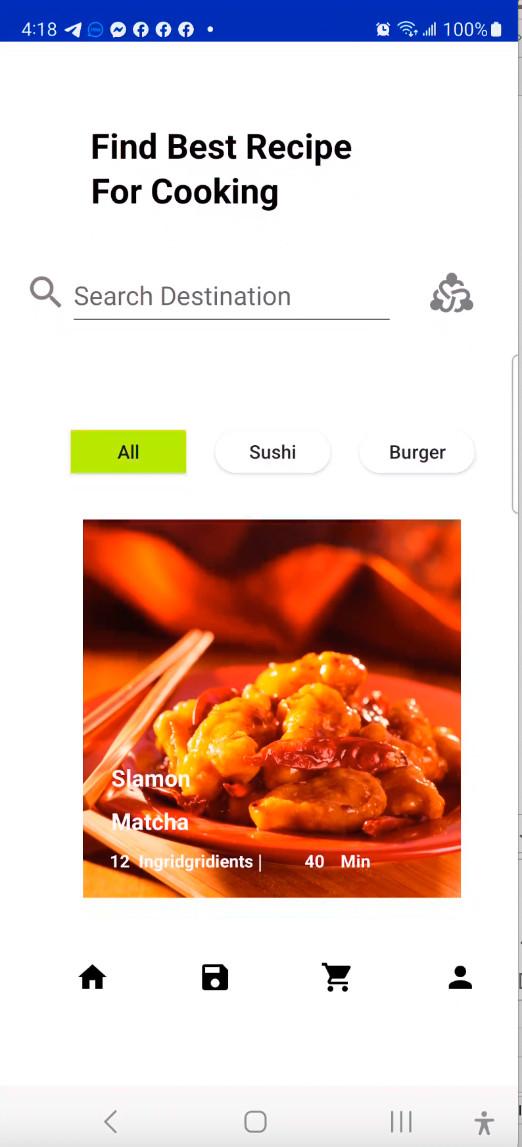 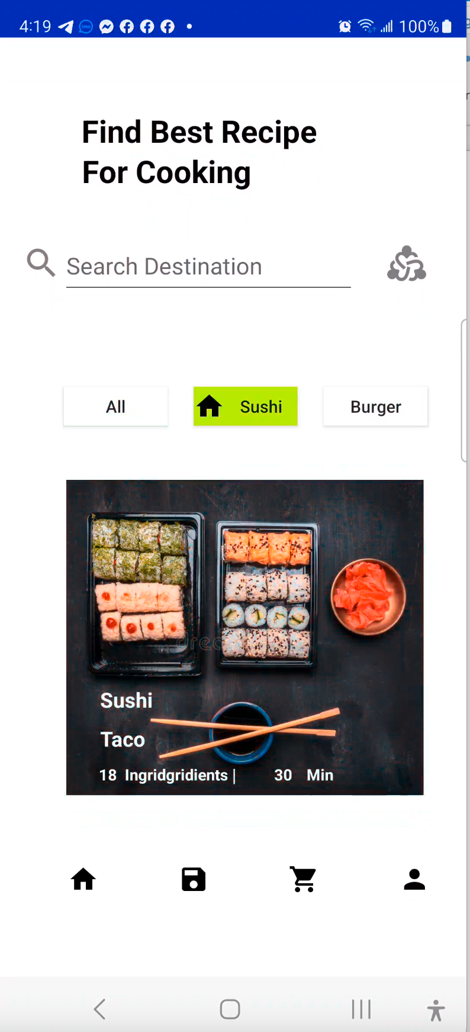 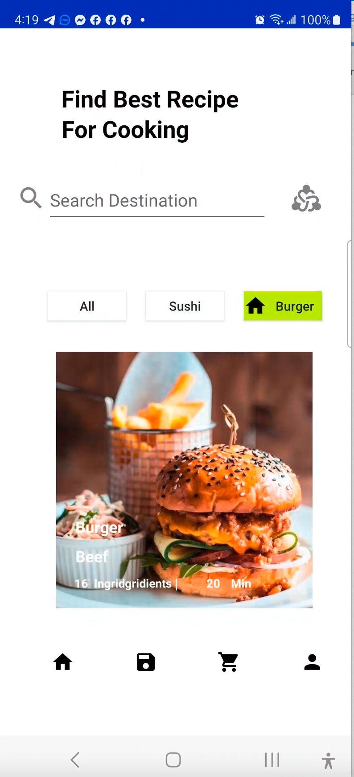

Third Screen,

when choosing a Meal by clicking the meal image in the previous screen, it will display its details and scrolling list view details which belongs to the selected meal

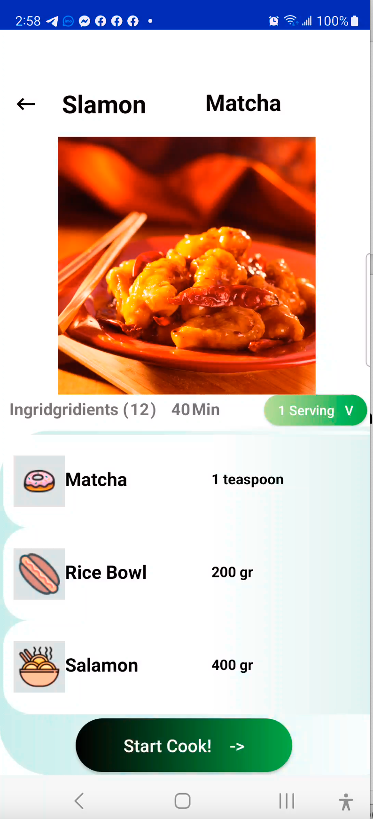 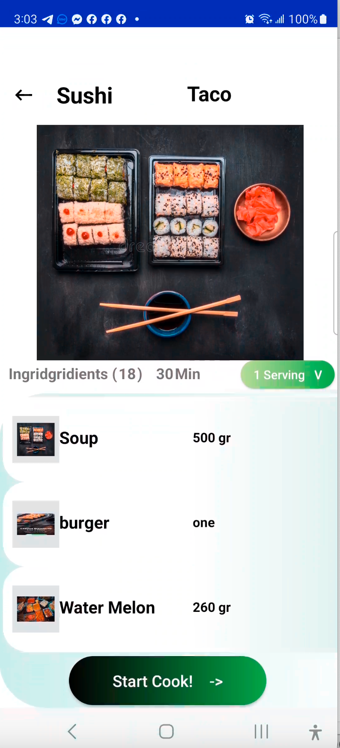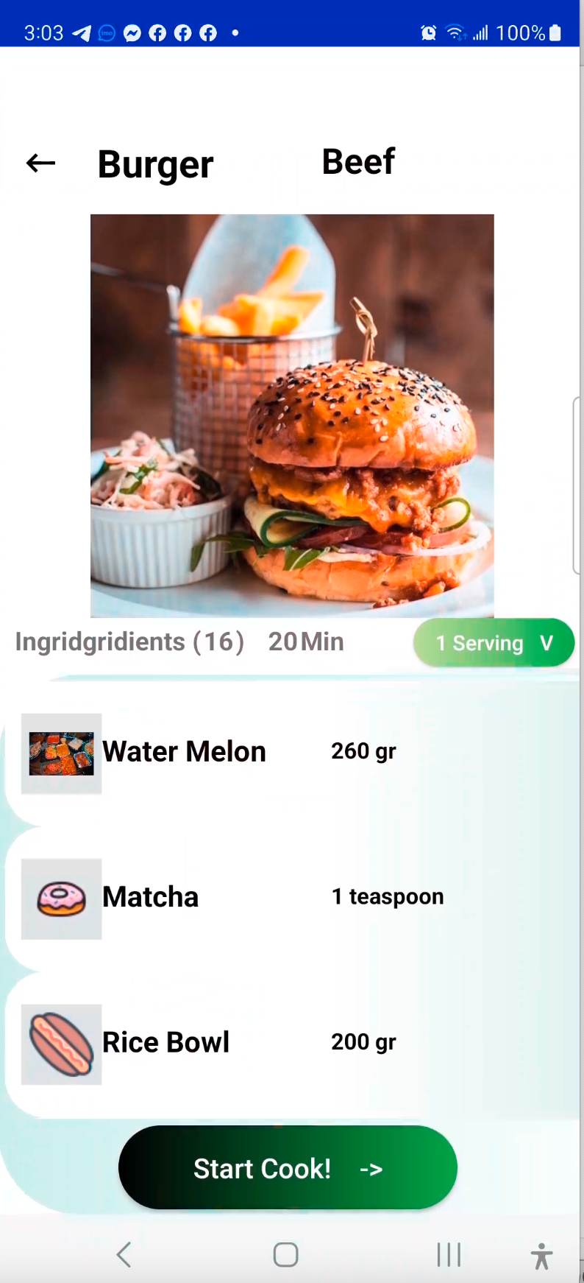

Click on List item text will go the main activity (just action)